Oakwood Cemetery Association Directors

Thomas S. Cook – President
Merilee Walker – Sec./Treas.
Katie Baldwin
Patricia Galbraith
James Mc Master
Robert Piper
Joan Schumaker

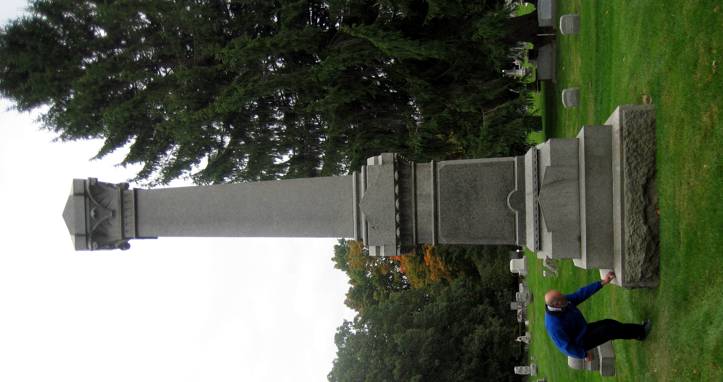

Donations to assist with cemetery restoration are gratefully accepted. Send to:

Oakwood Cemetery Assoc.
PO Box 242
Nunda, NY 14517

For more information on Oakwood Cemetery and the individuals who rest there, contact:

The Oakwood Cemetery Association
585-468-3492
585-468-5991

The Friends of Nunda Cemeteries, PO Box 22, Nunda, NY 14517

The Nunda Historical Society, 24 Portage St., PO Box 341, Nunda, NY 14517-0341
www.nundahistory.org

Nunda’s Historic
Oakwood Cemetery

Oakwood Cemetery Association
Est. 1865

Welcome to Oakwood
As you walk among the stones in Oakwood Cemetery you are journeying through two hundred years of Nunda area history. The names you see tell the stories of five generations of local families whose stories are the history of the Town and Village of Nunda.
The cemetery was first opened in 1822 as the valley was first being settled by pioneers. The first burial at the “Oak Knoll” was that of 19 year-old Amy Tuttle. The next year the remains of Granny Prentice were carried to the graveyard on a sled pulled by oxen. Although the exact locations of these graves have been lost, the Oak Knoll was in what is now known as OC1 (Old Cemetery 1) in the cemetery. There you will find the graves of many other pioneers, the earliest stone dating to 1829.
As Nunda grew, so did the cemetery. By 1860 the grounds had expanded to include both OC1 and OC2. In 1864 the village raised a tax of $25 to improve the grounds and repair the fences that kept local livestock out of the burial plots. The very next year local citizens organized the Oakwood Cemetery Association, a private not for profit organization to manage and care for the cemetery.

The new Association purchased additional acres from the Upson and Osgoodby families, more than doubling the size of the cemetery. The plans for the new grounds (sections A through I) reflected the contemporary “garden cemetery” movement with its winding roadways and landscaped paths. These sections opened in 1866, but contain several older gravestones. Many local families paid the sexton, Samuel Reckard, $6.00 to move a family member’s remains and their marker to the new sections.
The ornamental gateway on West Street was added in 1878. This gateway was removed in the early 1900’s, but the original sign is preserved on the Cemetery tool shed near the Gibbs Street entrance. The Soldier’s Monument was dedicated in 1897 and the cemetery vault and steps were built in the first decade of the twentieth century. New sections were also added to the 1865 plans. Section J is said to have originally been the Catholic burial grounds, while Sections K and L contain the later twentieth century burials. In recent years the Association has bought five additional acres of land to the west of the cemetery on Price Street to allow for future expansions.

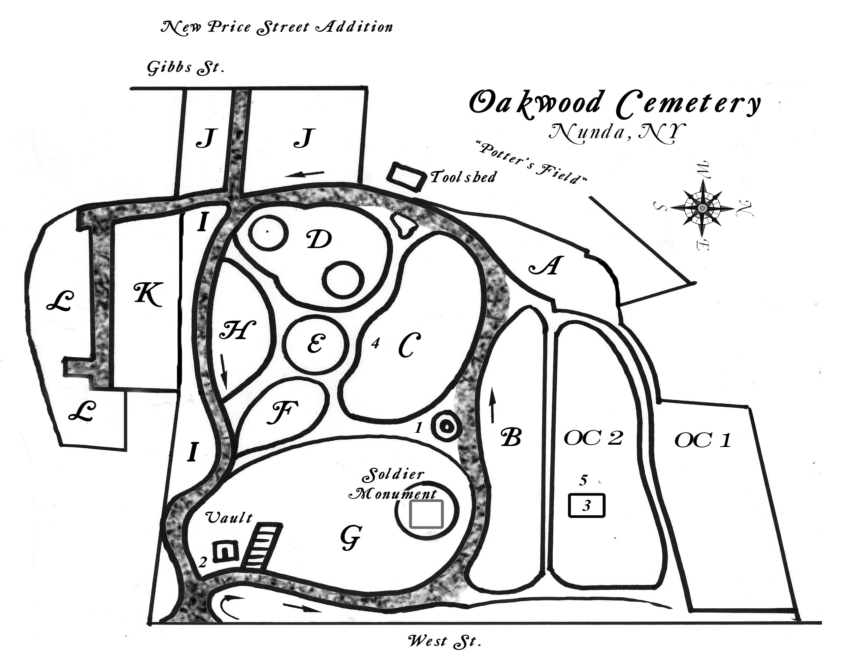
Key to Oakwood

OC 1 – Old Cemetery 1, 1822-1865
OC 2 – Old Cemetery 2, 1822-1865
Sec. A – I – 1865 - ~1900
Sec J – Old Catholic Division
Sec K – 20th Century Division
Sec L – 21st Century Division
Future development will be in the
New Price Street Addition

1 - Fountain Garden
2 - Revolutionary War Memorial
3 - Whitcomb/Richmond Vault
4 - Dowling Obelisk
5 - Micah Brooks Obelisk

Upon entering the cemetery, vehicles should bear right for traffic in a counterclockwise direction.

Today you can still walk through the old “Oak Knoll” or trace the garden paths -of the 1865 cemetery. Here are just a few of over four thousand stones and stories that can be found in Oakwood Cemetery:

Family Plot of the Micah Brooks family. Micah was an early pioneer who knew Mary Jemison well. He also served as a Congressman and local land developer. (OC2) (see #5)

Whitcomb/Richmond Family Vault - the story of Anna Elizabeth Richmond, member of a prominent 19th century family, was chronicled in the book “My Dearest Anna.” (OC2) (see #3)

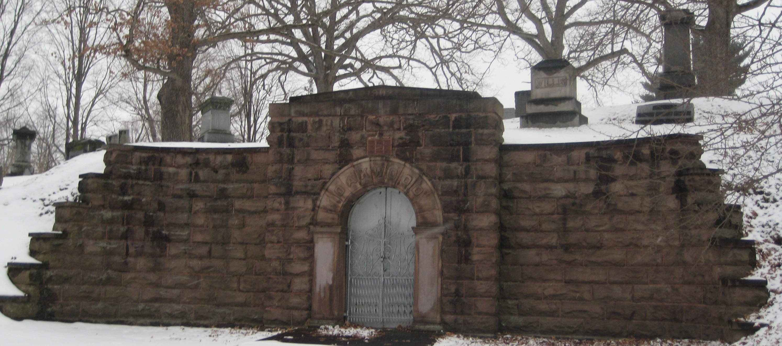
James Paine was the first permanent settler in the present lands of the town of Nunda. His descendants still live in the area. (Section B, east end near West St fence)

John W Emmons was not yet 16 when he died of fever in the Union army during the Civil War. (west end of Section B)

Richard Gay was a slave who escaped to the northern lines during the Civil War. He came north with the 1st NY Dragoons and lived out his life in Nunda.(west end section H)

- Obtain permission before any planting
- Glass blocks, jars, or vases not allowed
- Urns and decorations must be in line with
headstones
- Foundations for stones must be approved
prior to installation

We reserve the right to remove flowers, wreaths, trees, shrubs, and decorations deemed unsightly

Cemetery Regulations

The purpose of these regulations is to facilitate proper landscaping and maintenance of the cemetery. Please support us in these efforts.

Rose Shave was a nationally known artist whose work can be seen at the Nunda Historical Society Museum. (East end of Section I)
- Flowers and decorations to be removed by October 15
Christmas/winter decorations allowed between Dec.1 and April 1

Note: Water for plants will be available at the storage shed on
the west side of the cemetery beginning in 2011.

September 2010

